Solution Brief

NeuralSeek + IBM Fusion

Secure, No-Code AI for Regulated Enterprises

Executive Summary
Enterprises in regulated industries face a fundamental barrier to AI adoption: public-cloud LLMs and SaaS AI agents cannot guarantee data sovereignty, strict access control, or compliance with frameworks such as HIPAA, PCI-DSS, FINRA, GDPR, or CJIS. Sending prompts or documents to external endpoints risks exposure of sensitive information, while multi-tenant architectures introduce unacceptable uncertainty around data retention, cross-customer bleed, and auditability.
NeuralSeek + IBM Fusion solves this problem by delivering a fully governed, behind-the-firewall AI platform that transforms private enterprise data into production-ready applications—without exposing any information to external networks. NeuralSeek provides deterministic, source-grounded responses, while IBM Fusion enforces policy-driven orchestration, identity, and governance. Together, they unlock AI productivity gains while preserving complete control over data, workflows, and compliance.

The Problem: AI Adoption in Regulated Industries
Regulated organizations lack a unified, no-code way to operationalize AI using their private data. Key challenges include:
- Data sovereignty risks from public-cloud LLMs
- Inability to enforce zero-trust controls across external AI services
- Lack of auditability and traceability in model behavior
- Hallucinations and non-deterministic outputs
- Vendor lock-in and retention ambiguity
- Compliance exposure across HIPAA, PCI, FINRA, GDPR, CJIS, SOX, ITAR, and more
These industries require AI systems that operate inside their own security perimeter, with full governance, logging, and policy enforcement.

What NeuralSeek Provides
NeuralSeek is an enterprise AI platform designed for safe, compliant use of private data. It combines:
- Retrieval-augmented generation (RAG) for source-grounded answers
- Multi-LLM AI Agent orchestration for performance and cost control
- Strict governance including RBAC, PII filtering, and audit logging
- Deterministic, traceable outputs with verifiable citations
- Deployment flexibility: cloud or fully on-prem
NeuralSeek ensures that every answer is tied to approved internal sources—eliminating hallucinations and enabling compliance-ready AI.

What IBM Fusion Provides (IBM to elaborate)
IBM Fusion is a secure, on-premises platform for building and deploying AI applications without sending data to the public cloud. It delivers:
- Secure LLM orchestration
- Enterprise-grade governance and policy enforcement
- Deep integration with internal systems
- Hardware-rooted trust and isolated compute
- Support for Granite and open-source models
Fusion keeps every token, workflow, and dataset inside your firewall, ensuring full control over identity, access, and data movement.

Joint Value Proposition: NeuralSeek + IBM Fusion
Together, NeuralSeek and IBM Fusion create a uniquely powerful architecture for regulated industries to develop and deploy multi agent AI workflows.

1. Absolute Data Privacy & Sovereignty
When deployed on Fusion, NeuralSeek ensures:
- No external API calls
- No third-party data exposure
- No multi-tenant cloud risk
- No external logging or retention
All retrieval, reasoning, and orchestration remain fully contained within your infrastructure.

2. Deterministic, Source-Grounded Answers
NeuralSeek ties every response to approved internal sources, delivering:
- Highly accurate, auditable outputs
- Verifiable citations
- Confidence scoring
- Hallucination reduction
This is essential for legal, clinical, financial, and operational workflows.

3. Enterprise-Grade Governance
The combined stack provides:
- Granular RBAC
- Full audit logging
- Domain-specific content filtering
- Policy enforcement for sensitive data
- Guardrails for every agent action
AI behavior aligns with your compliance, privacy, and risk frameworks.

4. Safe Use of Private Data Without Model Retraining
NeuralSeek enables real-time retrieval from internal documents and systems without fine-tuning or exposing data to model providers.

5. Seamless Integration With Internal Systems
Fusion enables secure connectivity to:
- Databases
- File shares
- Knowledge repositories
- Identity systems (LDAP, SSO, RBAC)
- Line-of-business applications
AI agents can search, reason, and act safely inside your environment.

6. Compliance-Ready Architecture
The solution meets the strictest regulatory requirements:
- HIPAA
- PCI-DSS
- FINRA
- GDPR
- CJIS
- SOX
- ITAR
NeuralSeek ensures content-level compliance; Fusion ensures system-level compliance.

7. Faster, Safer Enterprise AI Deployment
NeuralSeek’s no-code configuration + Fusion’s orchestration layer delivers:
- Rapid deployment
- Minimal custom engineering
- Consistent governance across all use cases
- Lower operational risk

Use Cases Across Industries (Lawrence to enhance?)

AI-Powered PDF Research & Reports
Parallel retrieval from internal knowledge bases and the live web, synthesized into a polished, citation-rich PDF.

UGC Video Generation
Automated pipeline from script creation to scene prompts to rendered MP4—no human editing required.

SQL-to-PowerPoint Automation
NeuralSeek queries your warehouse, drafts charts and slides, and assembles a complete .pptx deck.

Client-Ready Email Automation
Slack-triggered email drafting with built-in confidence checks and human-in-the-loop escalation.

Meeting Preparation
Daily briefings generated from calendar events, CRM data, and live web research.
Architectual Overview & Diagram (Marc to provide)
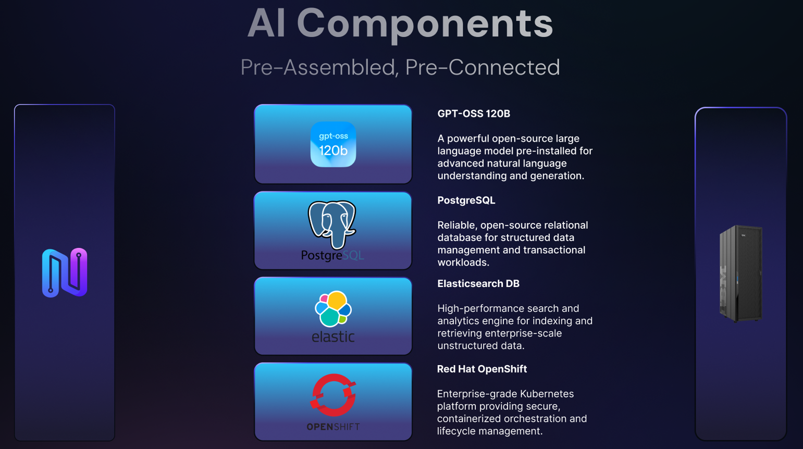
Guidelines & Sizing Recommendations (Marc/Lawrence to provide)
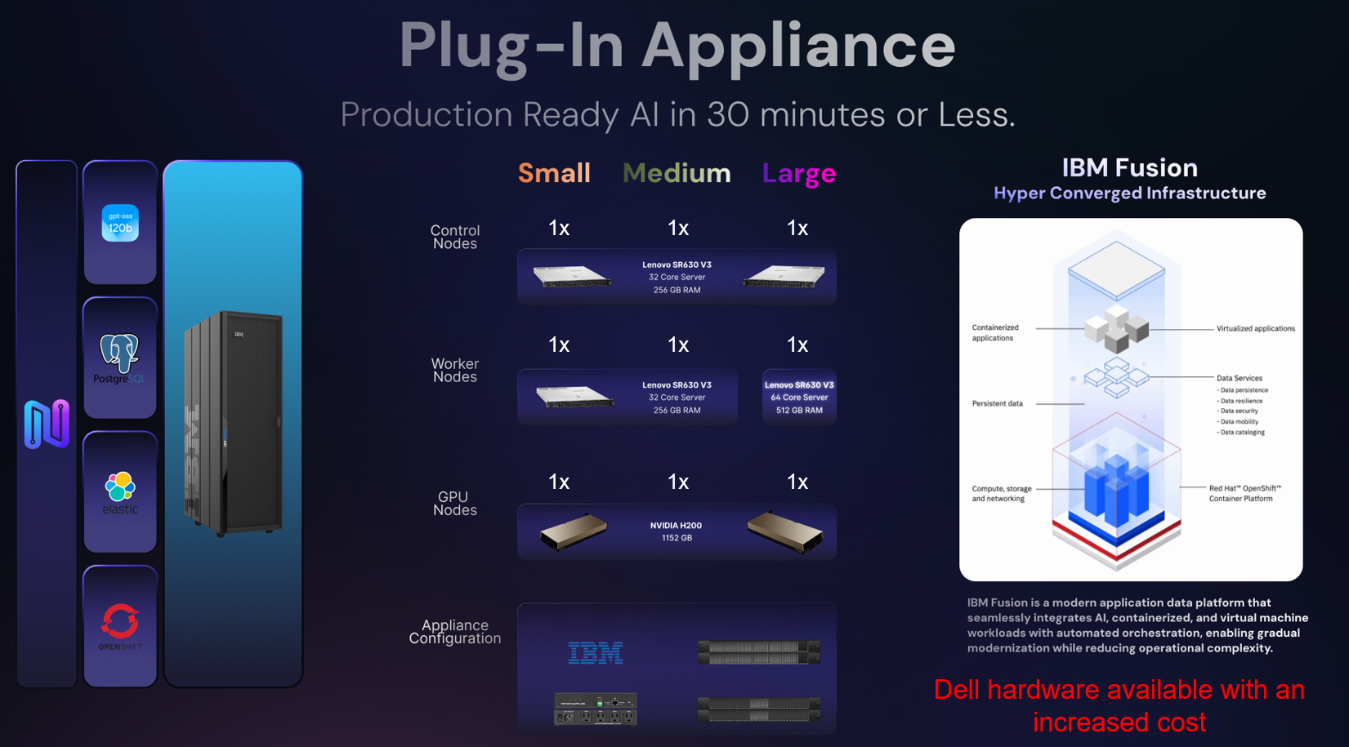

Conclusion
NeuralSeek + IBM Fusion is one of the few architectures capable of meeting the full stack of requirements demanded by regulated industries: security, governance, accuracy, auditability, and operational control. NeuralSeek solves the correctness and explainability problem; Fusion solves the data-sovereignty and governance problem. Together, they enable enterprises to move from prototypes to production-grade AI systems that regulators, auditors, and risk committees can trust.

